## **IDEAS**

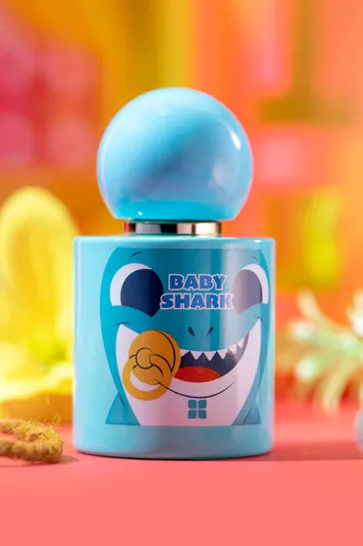

Baby Shark Blue Perfume

PKR 1,490.00

Baby Shark Blue is the perfect choice for kids as it embodies fun and innocence. Top notes of this playful spray feature spicy anise and fruity aromas. The fragrance lasts all day as the little ones play.

Size: 30ml Bottle

###### **Fragrance Category**

Floral Powdery Musky